REVEL-CSD-Batch 2-Web Copy-Careers Page-NB-12-06-2025

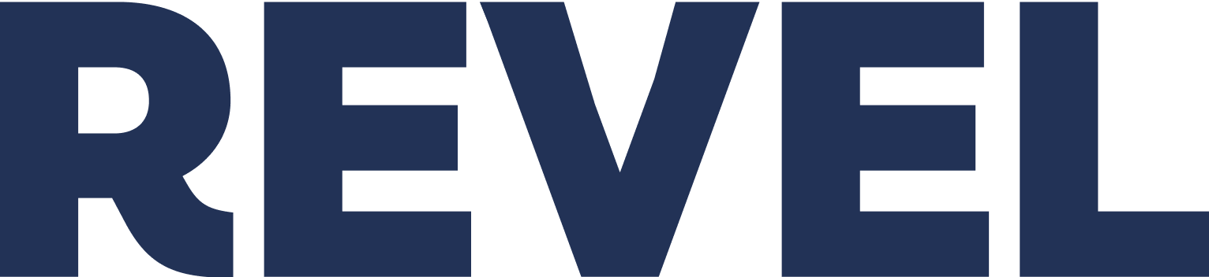

DRAFT FOR REVIEW
Careers / Work With Us page

The following Work With Us/Careers page draft copy and flow assumes a scrolling page with sections and takes into consideration best practices for an engaging Career page experience that drives CTR and application interest.
Here’s why:
Your Careers page is your most critical recruiting asset, meaning successful talent acquisition hinges on the Careers page structure. Leaders in recruitment typically feature 6 to 8 compelling narrative sections to fully articulate the Employee Value Proposition (EVP) and drive applications for a high-converting Careers page. This strategic segmentation ensures the brand's full story—from mission to growth opportunities—is communicated clearly and passionately to prospective employees.
Specifically…
- What you convey on your Careers pages need to make a lasting, positive impression.
  - Stats show 6 in 10 candidates visit a brand’s career page before applying.
- You need to be bold, not boring—and honest.
  - Accoladed example: Shopify # Not Everyone Can Do This
- Wear your mission and values as a badge of honor to guide candidates from curiosity to application, conveyed in simple, powerful terms—and don’t be afraid of taking the words to say it:
  - Accoladed example: Ghost
  - Accoladed example: Canva’s Two-Step Plan
- Show, don’t just tell. Before applying, people visiting this page are evaluating you and the brand, wanting to know what you stand for, and what the experience of working for the brand looks like. Show it—use high-impact videos showcasing the experience of working at CSD. Examples:
    - A Day In the Life Of…a clinician, a BCBA, etc.
    - Show what it’s like to be in a role, but also show the CSD extras, especially how you invest in your team members career growth.
      - Videos on Career Compass, CSD University, and the Dreams Come True Program
      - Feature both the serious and the fun sides of working at CSD
        - A sizzle reel showcasing the neurodivergent advisory board
        - Team celebrations
        - A video of what a new teammember’s onboarding week may look like
      - Show what life working at CSD is like.
        - Accoladed example: Life at Uber
- Highlight Diversity, Equity, and Inclusion
  - Message your passion supporting DEI
    - Feature your Neurodivergent Advisory Board
- Include powerful, visual, leadership team and employee testimonials using authentic storytelling about team members’ career journeys to humanize what it’s like to work for the company.
  - Example: Chipotle’s testimonials carousel of imagery and quotes (scroll down to the 5th section)
- Own bragging rights for any awards
- Message in ways that are impactful, differentiated, high-conversion (this requires thoughtful A/B CTR testing)
- Provide multiple strong, powerful, engaging CTA button opportunities, so that potential applicants hooked as they read down the page can immediately explore your current career openings listing page, and to ensure they know exactly what to do next.
- Avoid jargon.
  - As throughout the new brand pages, use warm, welcoming, and accessible yet impactful language.
- Emphasize CSD’s differentiators.
  - Explicit that CSD “is not just another ABA provider.”
  - Emphasizes CSD’s combination of “rigorous, evidence-based science” and “wildly relentless compassion, commitment, empathy, and heart”—for its team members as well as caregiver and family clients.
- Uses strong headings making the page highly scannable.
- Featured high-impact, professionally produced images and videos showing real employees.
- Of note, top performing and high-conversion Career pages are paired with a sharp, geo-targeted social media campaign.
Check out the content and design of these accoladed Career pages. You’ll see themes of best practices:
Canva
Chipotle
Doist
EY
Harvest
HubStaff
Perspective
Recharge
Shopify
Starbucks
Uber
Veed
Wise

To overcome your recruiting constraints and impact on the overall business, consider Investing in your Work With Us page by engaging a career site builder or career site builder software to develop a maximized, high-conversion Career page UX/UI that seamlessly integrates with your site brand experience, to turn curious prospects into committed applicants. The following offer demos of how their built career experiences can optimize engaging applicants. The following are just a sampling. There are many out there at different price points:
Ongig
Phenom People
ICIMS
Symphony Talent

Please note, this document is to show copy and sections flow priority for wireframe and design guidance for a site relaunch. However, copy can be switched into the current design for early testing, and where minimal effort would be required for section replacements.
CSD-DRAFT-Career Page copy

………………………………………………………………………………………………………………………………………………………..

Maximize Your Impact and Accelerate Your Growth

CSD’s culture of collaboration, purpose, and care for the whole person extends to our team members. Join us to make a difference in the world and unlock possibilities in your own career.

Join Our CSD Family
CTA button: Browse Open Roles and Apply Now

__________________________________________________

Why Work With Us?

Raising the Bar for ABA Excellence

CSD is not just another ABA provider. We are the architects of possibility for children and teens with autism and ASD—and the clinicians and therapists who serve them. We stand at the intersection of compassion and evidence, where human connection meets clinical excellence.

Where Innovation Meets Passion

In an industry known for burnout and turnover, we do things differently. We care about you as much as our clients. We invest in you—the person who delivers life-changing breakthroughs on a daily basis, creating a professional community where innovation meets compassion, and your voice matters.

Advocating for Diversity in Everything We Do

As champions for neurodivergent children, we practice what we preach. Our CSD family is diverse, and our Neurodivergent Advisory Board made up of team members deeply influences how we work.

Free College

Yes! You read that right. We invest in you to grow your career potential, and promote your success—100% funding your college degree.

__________________________________________________

Our Core Promise to You—and Every CSD Team Member

- You will be supported: We prioritize self-care and professional development.
- You will grow: We offer 100% paid education, mentorship, and clear career pathways—prioritizing promotion from within our CSD family.
- You will feel purpose: Every day, you’ll be an integral part of our mission to ensure no family waits for the care their child needs.

__________________________________________________
Hear from Our Team

Don’t just take our word for it. Here’s what our BCBAs, RBTs, therapists, clinicians, and operational team members have to say.

[Video teaser] “Your dedication changes lives. We’re here to support YOU.”
[Video: Feature prominent clinician / care role stories, leveraging existing “Career Compass” or new video testimonials sizzle reel or individual videos in a carousel or rotating through]

Why You Matter to Us

A Message From Our Wildly Supportive, Heart-Centered CEO

[Video]

__________________________________________________
Your Career Pathway at CSD

We’re looking for passionate, growth-focused individuals ready to make a deep impact as a Clinician, BCBA, or essential Administrative Professional.

Direct Care Roles
Clinicians, BCBAs, BCaBAs, ABA Therapists

- Your mission: To partner with families, designing custom-crafted ABA journeys to success that make learning feel like an adventure, leading to real-life breakthroughs.
- Why CSD? Receive top-tier clinical supervision and enjoy autonomy, competitive compensation, and the support necessary to deliver evidence-based, fun, and effective care.

CTA button: View Open Direct Care Roles

Administrative & Operations Roles

- Your mission: To be the essential support that ensures every family and clinician has a smooth, compassionate experience—making exceptional care accessible and efficient.
- Why CSD? Be part of the team driving our sophisticated yet heart-centered operations, helping scale quality and accessibility nationwide.

CTA button: View Open Operational Roles

__________________________________________________
The CSD ‘Dream Academy' Advantage

Your education is our investment. We offer engaging and robust programs designed to help you reach your highest professional potential.

Dream Big, Launch Your BCBA Career
Free College, 100% Funded by CSD!

We are fiercely committed to promoting from within and helping our team advance their clinical education. Learn about our industry-leading pathway that offers financial support and mentorship to become a Board Certified Behavior Analyst (BCBA).

- How? Achieve your certification and advanced degree with the full support and financial backing of CSD.
- Why? In an industry plagued by burnout and high turnover, we invest in compassionate people who care about helping children with autism light up and learn.

CTA button: Yes, I’m Interested in a Degree Program

[Video + Dream Academy Testimonials

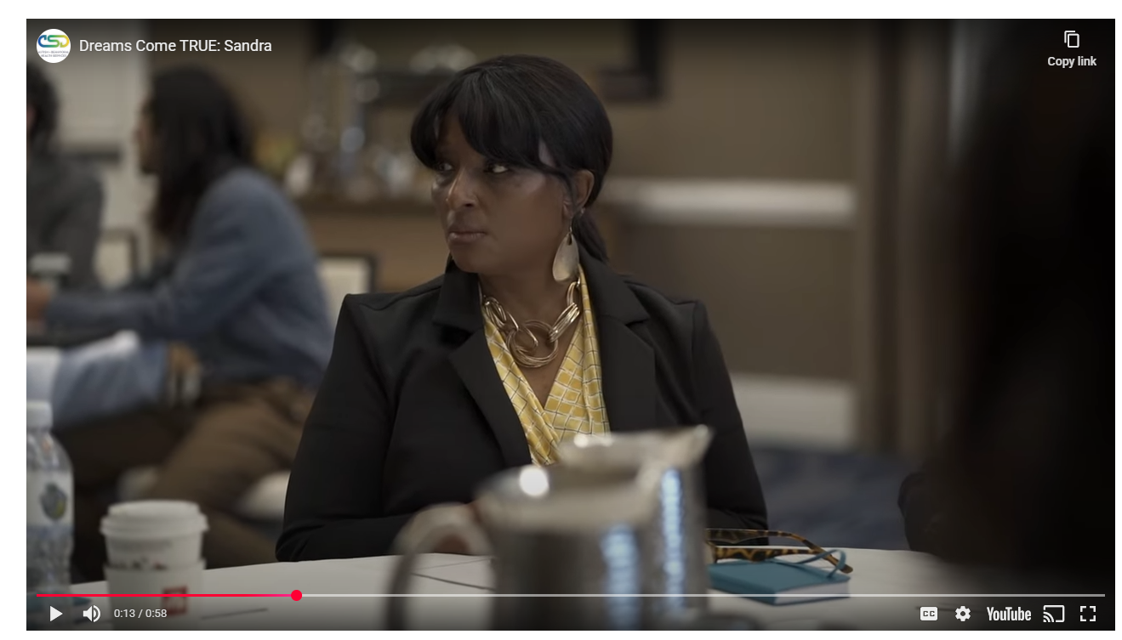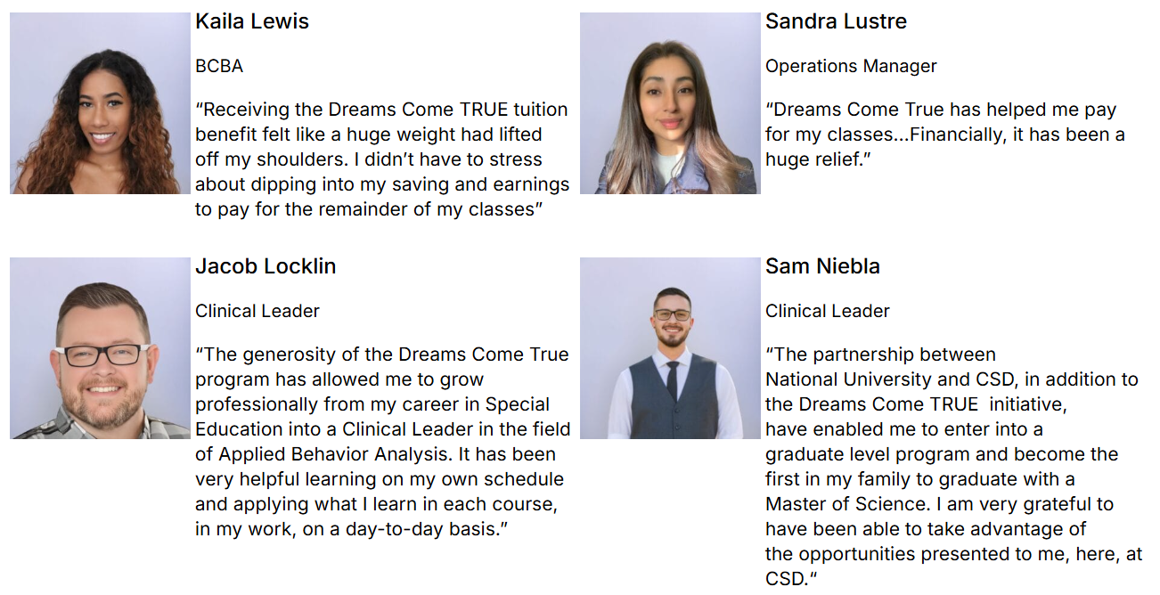

Ready to Join Our Change-Making CSD Family?

Grow your career. Evolve your education. Celebrate breakthroughs.

Apply in minutes and take the first step towards a fulfilling, heart-centered, fiercely supportive career.

CTA button: View Open Roles in Your Area

__________________________________________________
CSD’s Values
Our North Star
It’s not just about what you do.
It’s who you are and the impact you make that set you apart.

Our Mission
CSD opens a world of possibilities—by making the world possible—for children with autism and their families.

We do this through compassionate, individually tailored, evidence-based care that meets you exactly where you are, guiding your child to success on an innovative, breakthrough ABA journey to successful skill building.

Our Values

CSD’s Guiding Principles

Resilience through support
We know this work is hard. That's why we invest in our clinicians’ growth, well-being, and professional development.

Partnership over prescription
Families are the true experts about their children. Our role is to listen and co-create ABA therapy plans for every family’s goals, culture, and values.

Innovation rooted in humanity
We push the boundaries of what ABA therapy can be, but never lose sight of the human moments that matter most.

Science meets heart
Data guides us. Empathy drives us. Every therapy plan is evidence-based and deeply personal.

Access as a right, not a privilege
We design our program around one question: How do we bring exceptional care to every child who needs it—regardless of where they are, who they are, or their culture?

Humility in practice.
Our commitment to continuous improvement makes us better practitioners, advocates, and care providers.

Join the CSD family today!
CTA button: APPLY NOW

__________________________________________________

We’re Leaders in Our Field. You Can Be, Too!

We take the time to celebrate you and CSD’s achievements.

[Feature strip showcasing awards received]

__________________________________________________

[Footer]

OVERFLOW:

The CSD Difference
A Career Designed for YOUR Success

Our commitment to our clients is matched only by our commitment to our team. Here’s what sets a CSD career apart:

Investment in YOUR Growth: Paid Education & Mentorship
Evolve your career through our fully funded CSD University and Dream Academy to advance your education and promotional path, including BCBA mentoring, RBT certification, and paid CEUs done during work hours, not on your own time.

Industry-Leading Innovation: Help Shape the Future of ABA Therapy
Work with cutting-edge, one-of-a-kind ABA education tools, including custom-crafted gamified virtual sessions that you get to personalize for each child’s success.

High-Touch Culture: Consistency and Community
Work alongside passionate and satisfied colleagues who stay because they feel supported—allowing you to feel fulfilled and appreciated providing children the continuity of care they desperately need and deserve.

Accessibility Is Our Standard: Maximize Your Impact
As part of the CSD family team of clinicians and therapists, you’ll have the opportunity to serve all ages, complex cases, and diverse, multilingual families, to expand your experience and reach On the admin and operational team, you’ll provide critical support to ensure efficient and compassionate delivery of services.

CTA button: Come Work With Us

